**2+6 connector document**

* **Revision Number:**  
  Rev. 1.0
* **Date of Creation or Update:**  
  29/12/2024
* **Prepared By:**  
  Muhammad .Sulaiman Shahid
* **Reviewed By:**
* **Approved By**

**Introduction to 2+6 Connector**

The 2+6 connector is a specialized type of electrical connector widely used in EV charging infrastructure and industrial applications. It combines two primary power pins (2) and six auxiliary pins (6) to support both high-power transmission and additional communication or control functions.

**Key Features:**

1. **High Power Transmission**:  
   The two primary pins are designed to handle significant electrical loads, making the connector suitable for applications requiring robust power delivery, such as EV fast chargers.
2. **Auxiliary Functions**:  
   The six auxiliary pins facilitate communication, control, or auxiliary power functions, ensuring seamless operation and integration with various systems.
3. **Versatility**:  
   Its design makes it adaptable for use in multiple environments, including EV charging stations, industrial machinery, and other high-demand applications.
4. **Durability**:  
   The connector is typically built with high-quality materials to withstand environmental stresses, ensuring long-term reliability.

This connector plays a crucial role in advancing EV technology by ensuring efficient and reliable power delivery along with necessary communication capabilities.

Top of Form

Bottom of Form

**Sample harness of 2+6 connector**

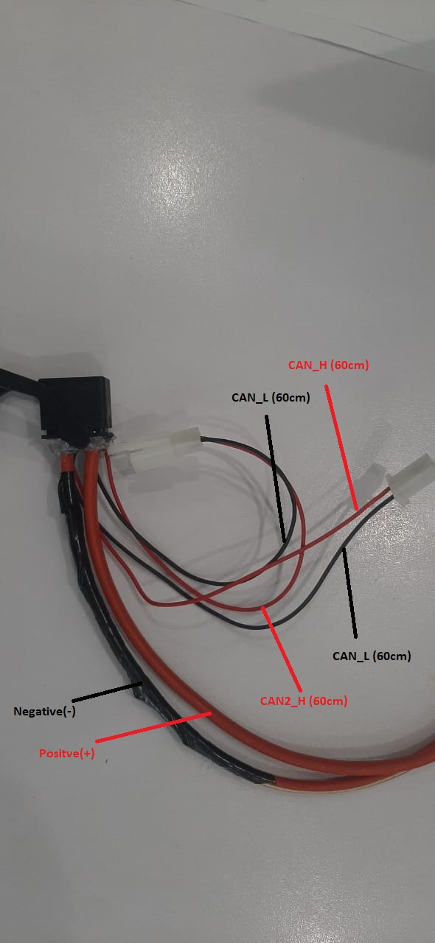

This sample harness of 2+6 connector has been provided to the supply chain team to be modified and replaced with an Anderson connector, as previously utilized in the bike HV harness diagram.

**HV harness diagram**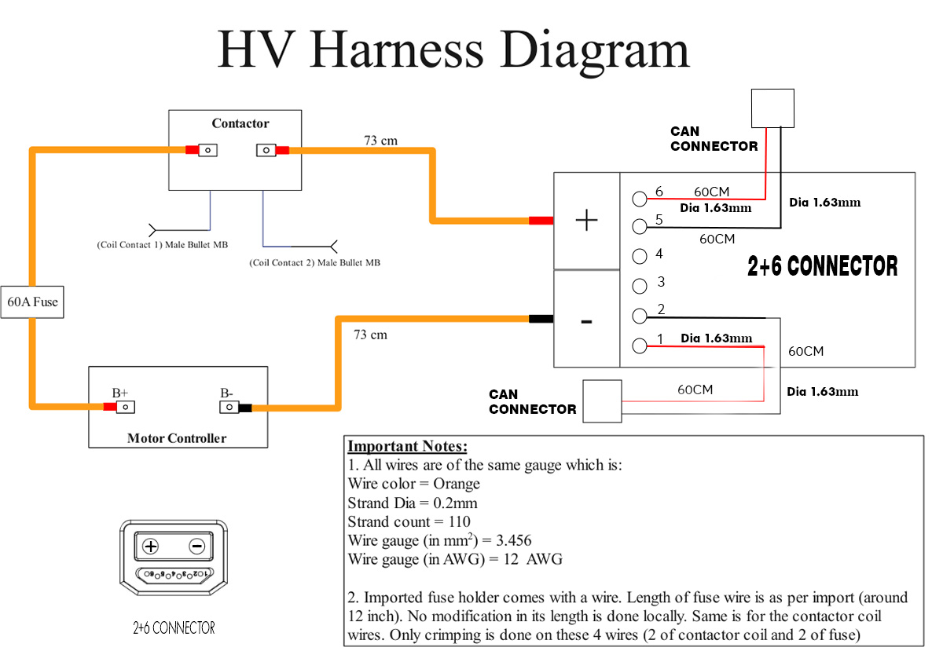

This is the HV harness diagram in which the Anderson connector has been replaced with a 2+6 connector. The auxiliary pins of the 2+6 connector are utilized for transmitting CAN data.  
Length of CAN data **wire in 60cm** and **diameter is 1.63mm**